ORACLE LAB

BCA-DS-552

**Manav Rachna International Institute of Research and Studies School of Computer Applications**

**Department of Computer Applications**

|  |  |
| --- | --- |
| **Submitted By** | |
| **Student Name** | **Harsh** |
| **Roll No** | **22/FCA/BCA(AI&ML)/013** |
| **Program** | **Bachelor of Computer Applications** |
| **Semester** | **5th Semester** |
| **Section** | **E** |
| **Department** | **Computer Applications** |
| **Batch** | **2022-25** |
|  | |
| **Submitted To** | |
| **Faculty Name** | **Ms. Iram Fatima** |

|  |  |
| --- | --- |
|  | **SCHOOL OF COMPUTER APPLICATIONS** |

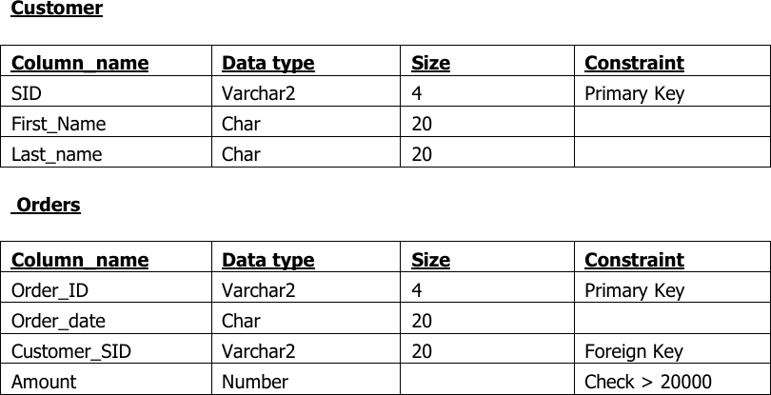**AIM**: Create the following table.

### Output:

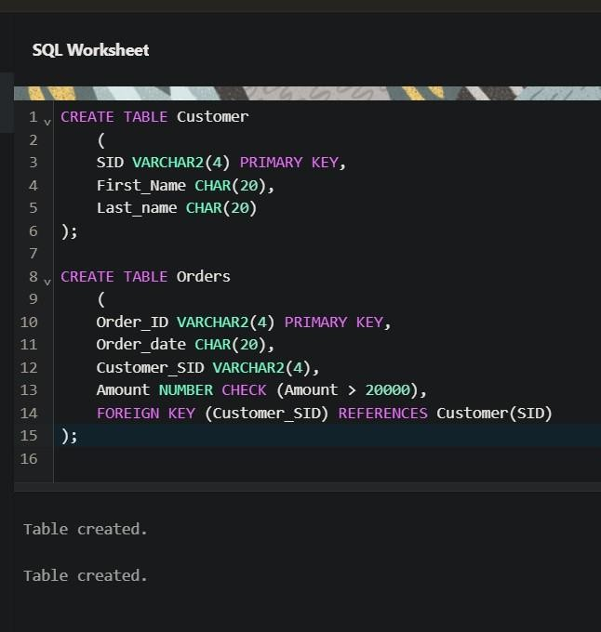

**AIM:** Insert 5 records for each table.

### Output:

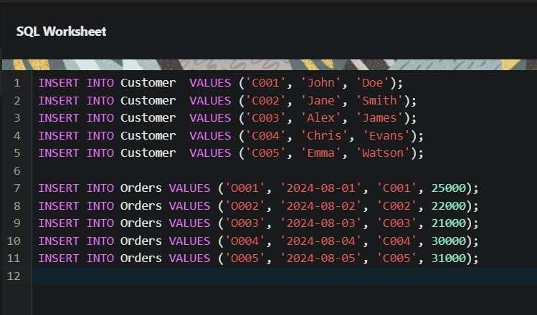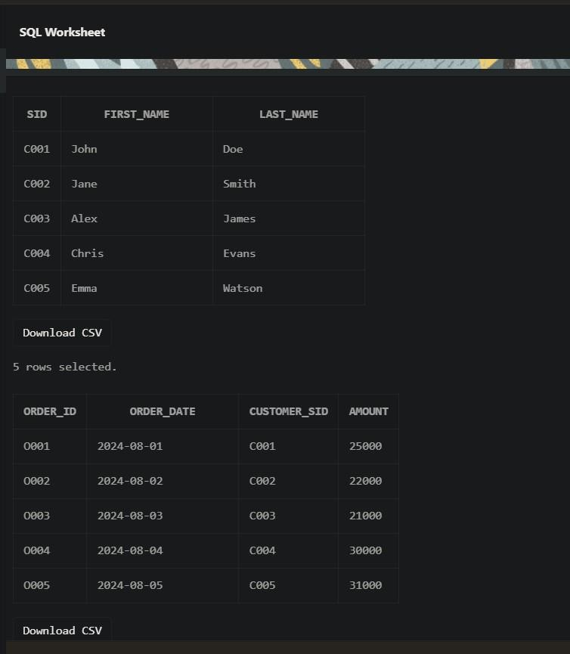

**AIM:** Customer SID column in the ORDERS table is a foreign key pointing to the SIDcolumn in the CUSTOMER table.

**Output:**

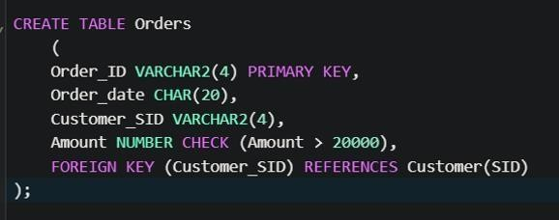

# EXERCISE 4

**AIM:** List the details of the customers along with the amount.

### Output:

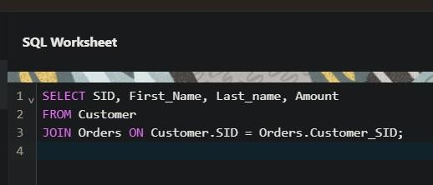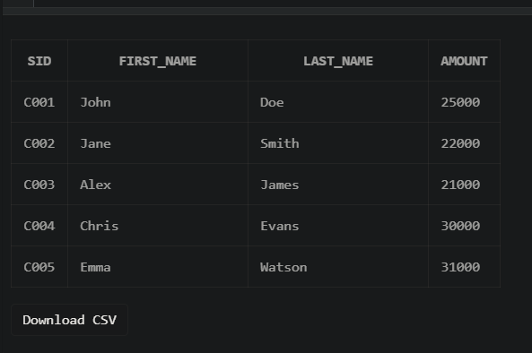

**AIM:** List the customers whose names end with “s”.

### Output:

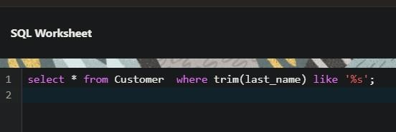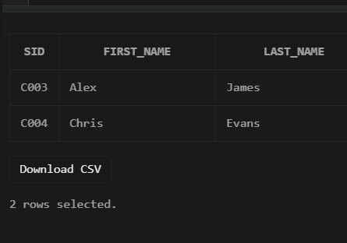

**AIM:** List the orders where amount is between 21000 and 30000

### Output:

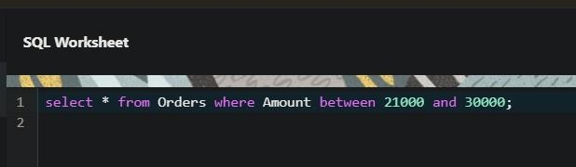

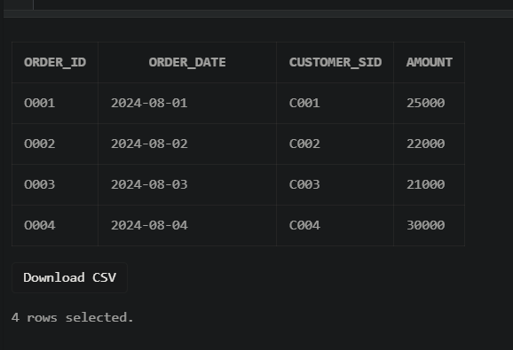

**AIM:** List the orders where amount is increased by 500 and replace with name “newamount”**.**

### Output:

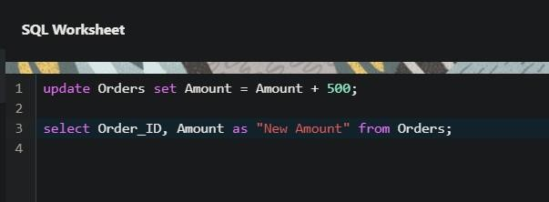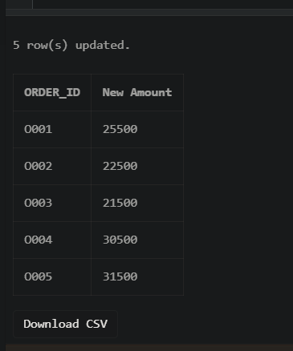

**AIM:** Display the order_id and total amount of orders.

### Output:

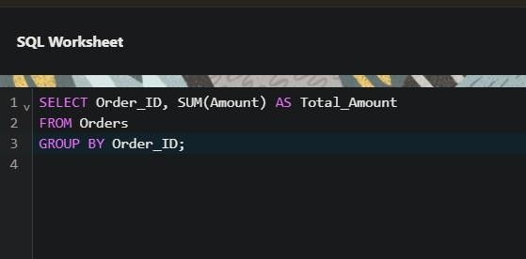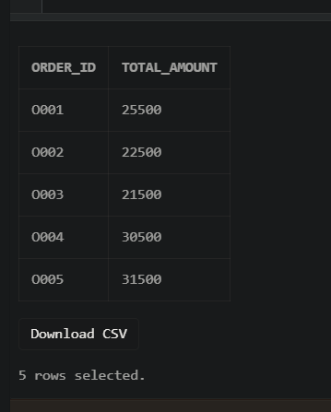

**AIM:** Calculate the total amount of orders that has more than 15000.

### Output:

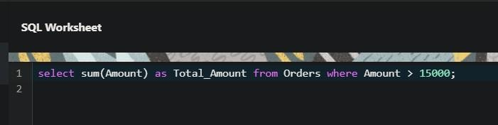

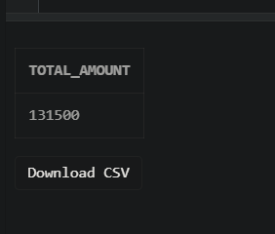

SELECT

LOWER('ORACLE') AS "Lowercase", -- Converts string to lowercase UPPER('oracle') AS "Uppercase", -- Converts string to uppercase SUBSTR('ORACLE', 2, 3) AS "Substring", -- Extracts substring LENGTH('ORACLE') AS "Length”, -- Returns length of string INSTR('ORACLE', 'A') AS "Position", -- Returns position of a character LPAD('123', 5, '0') AS "Left Padding", -- Pads a string on the left RPAD('123', 5, '0') AS "Right Padding",-- Pads a string on the right TRIM('O' FROM 'ORACLE') AS "Trimmed" -- Trims a specified character

FROM DUAL;

**AIM:** Create the following tables.

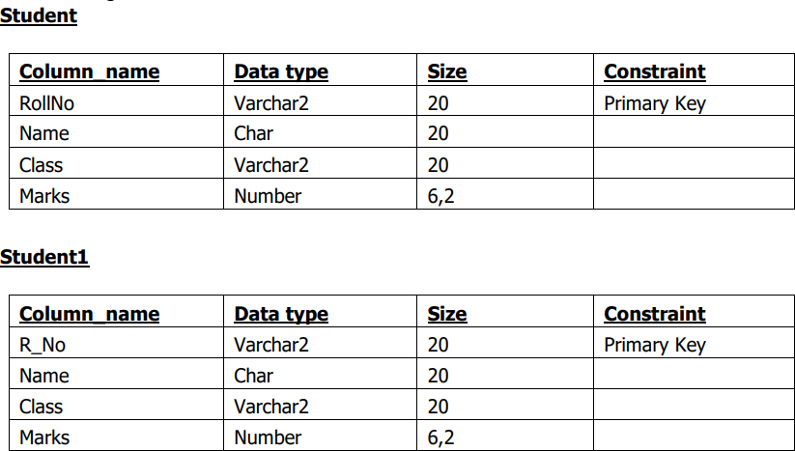

**Output:**

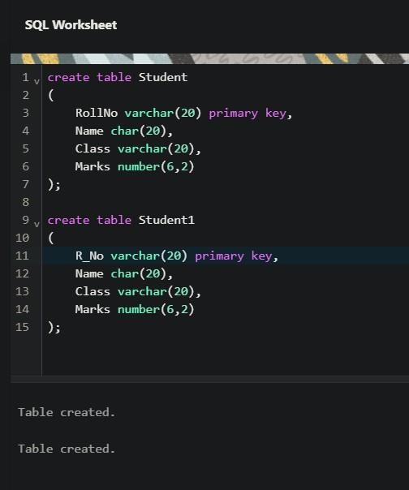

# EXERCISE 12

**AIM:** Display all the contents of student and student1 using union clause.First insert 5 records in each table i.e. Student and Student1

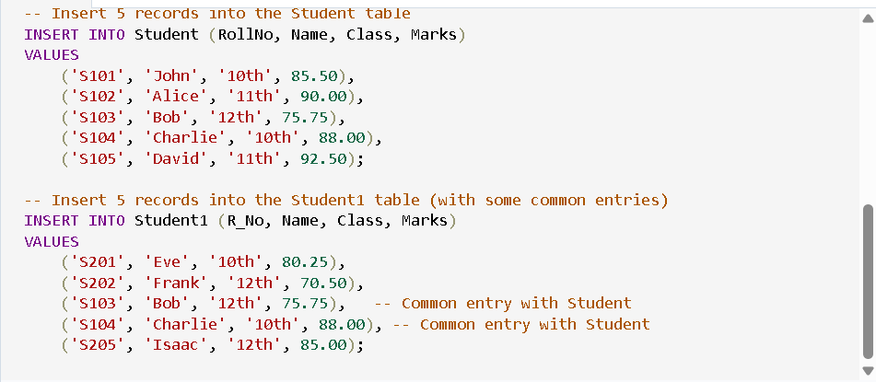

**Output:**

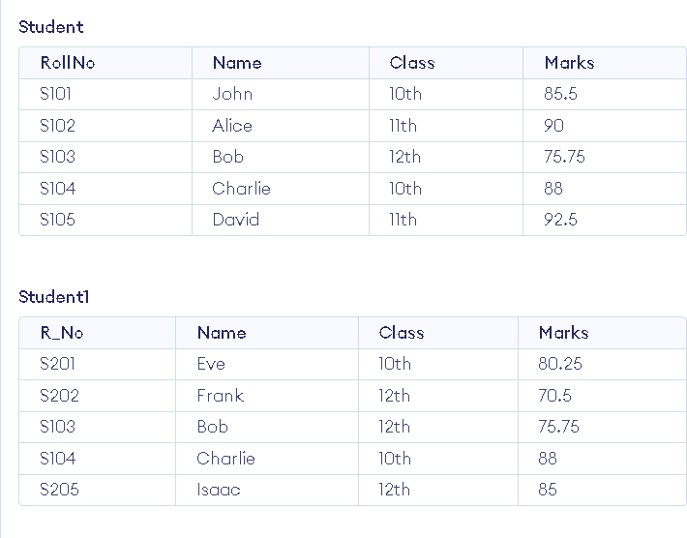

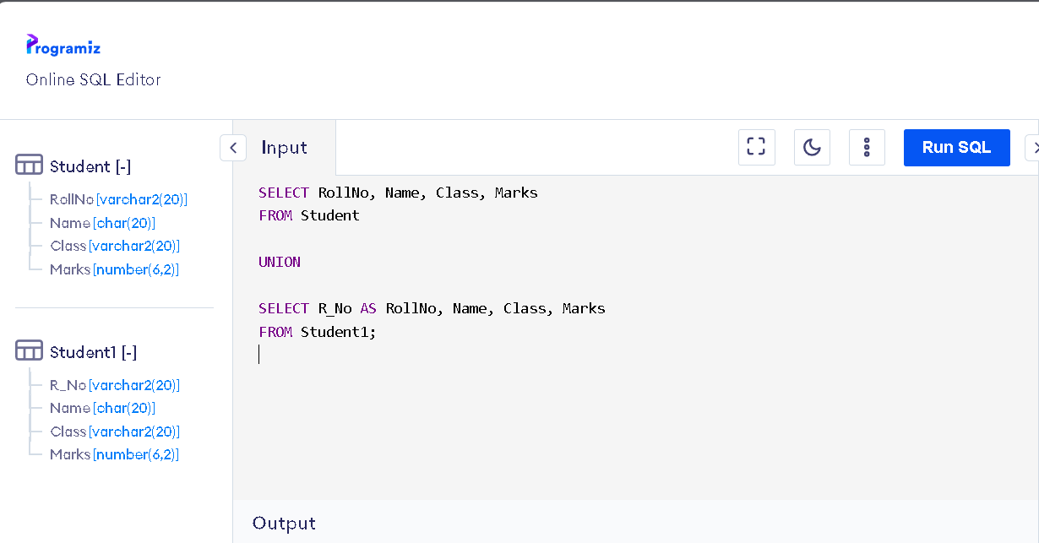

**Now union:**

**Output:**

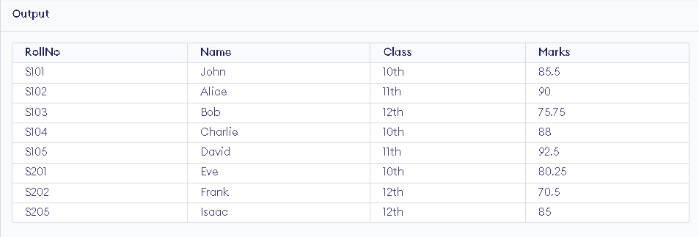

**AIM:** Find out the intersection of student and student1 tables.

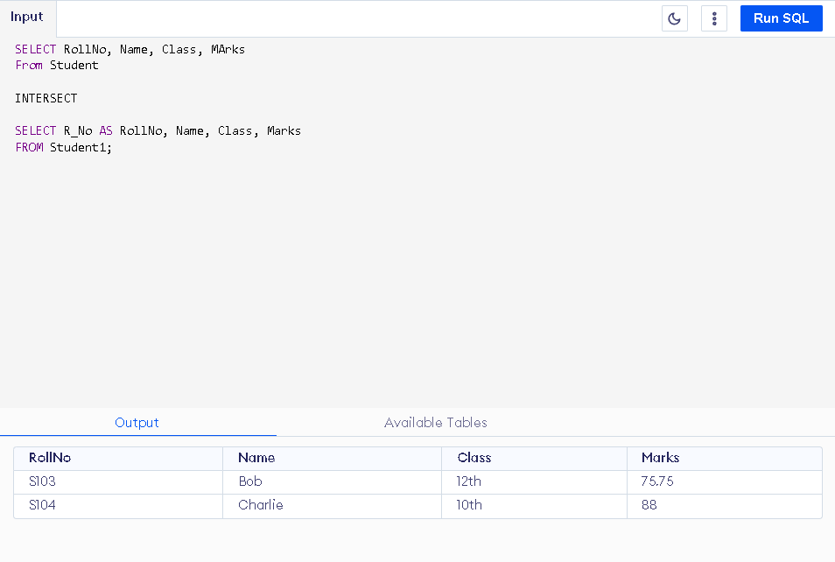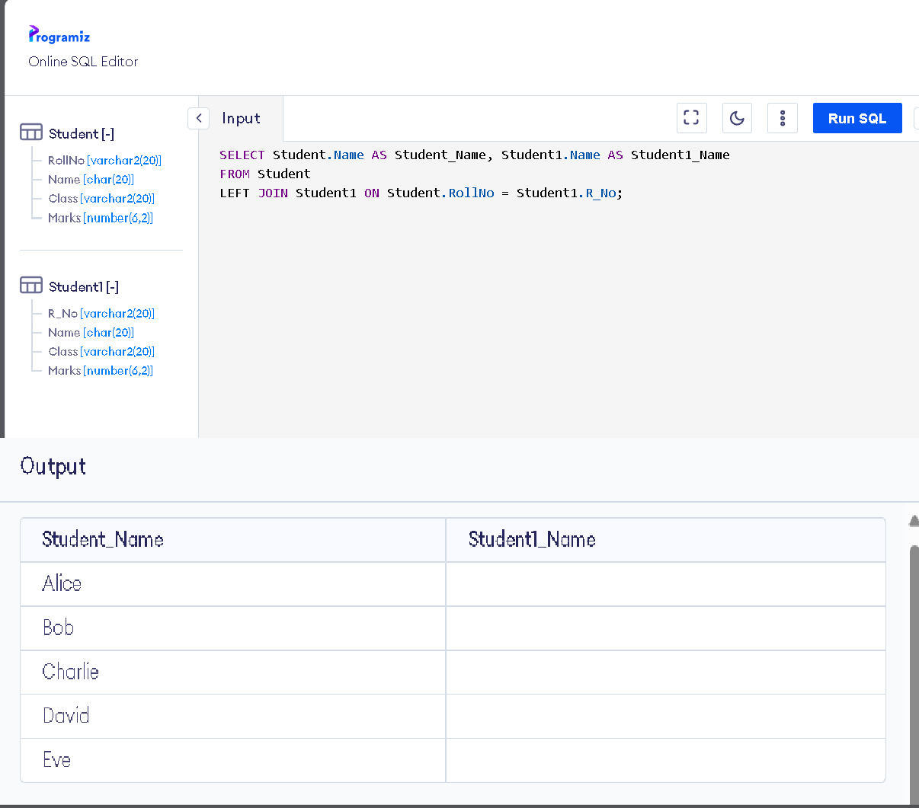

**AIM**: Display the names of student and student1 tables using left, right, inner and full join.

**INNER JOIN**

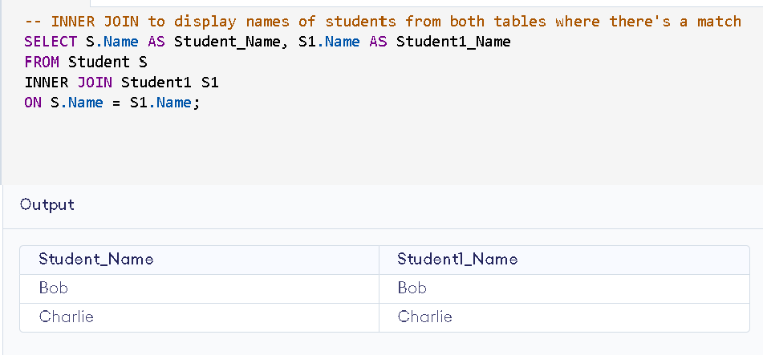

**LEFT JOIN AND RIGHT JOIN**

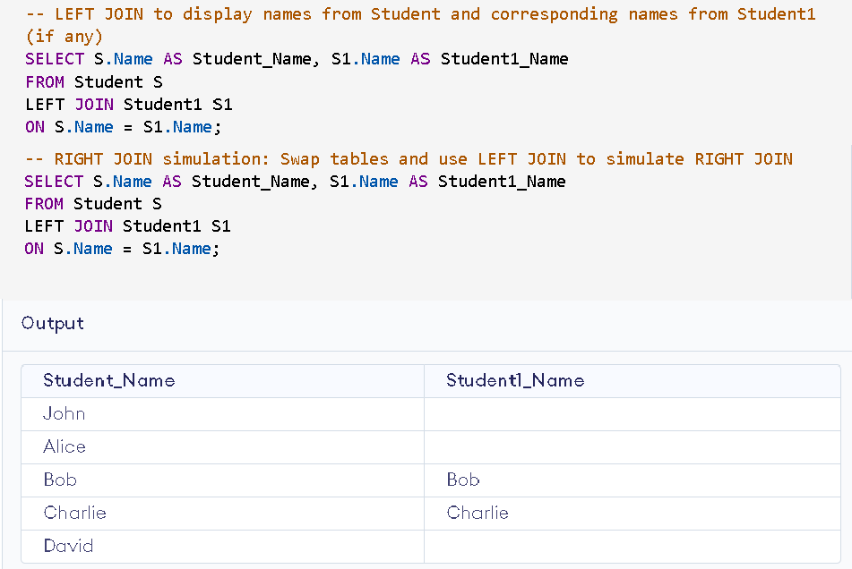

**FULL JOIN**

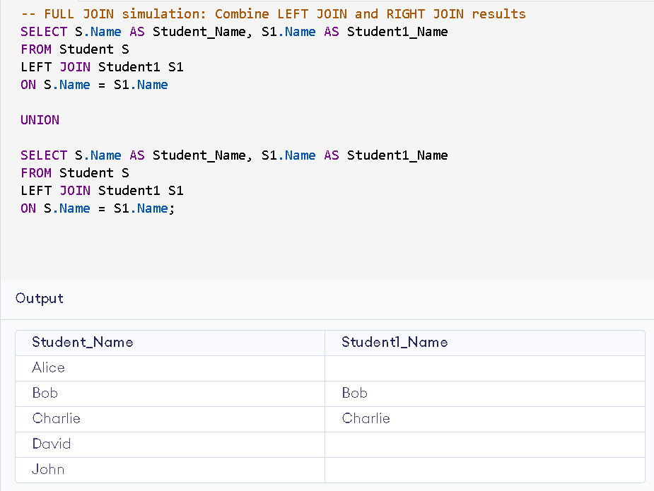

# Exercise 15

**AIM:** To Write a PL/SQL block to calculate total salary of employee

having employee number100.

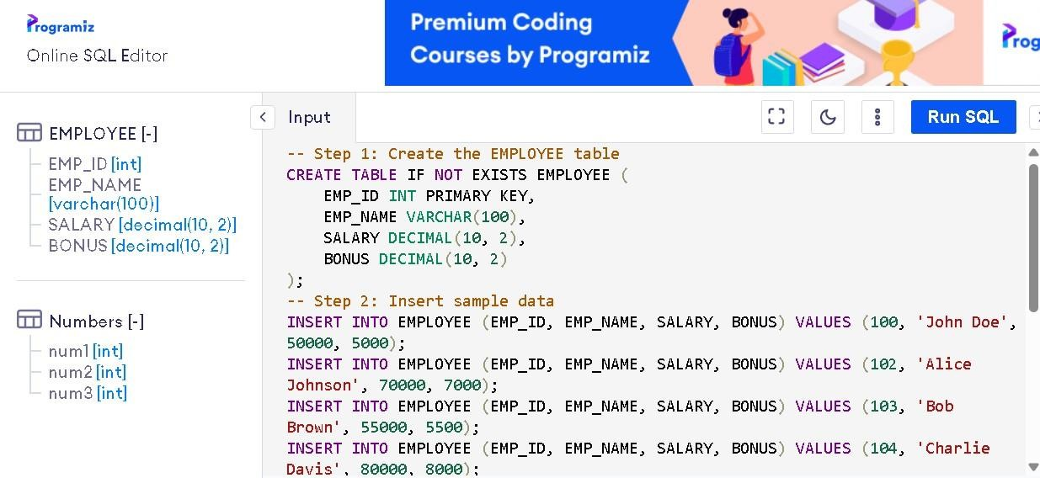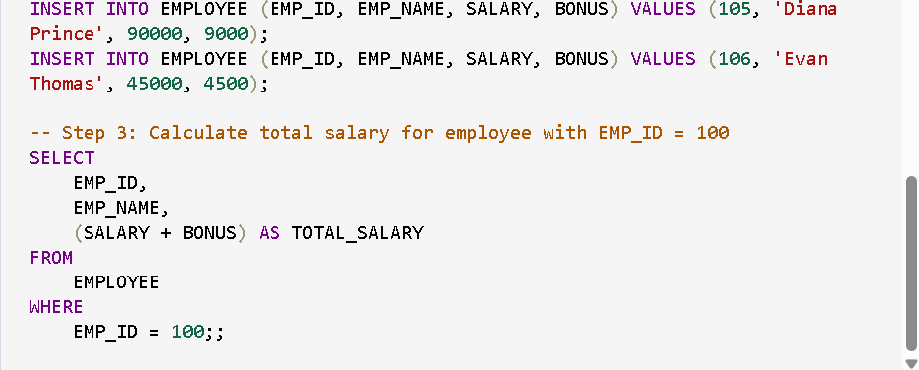

**OUTPUT:**

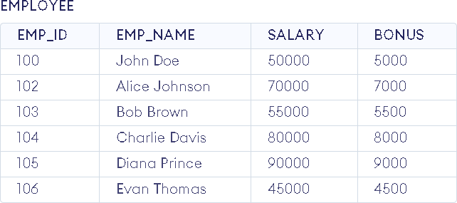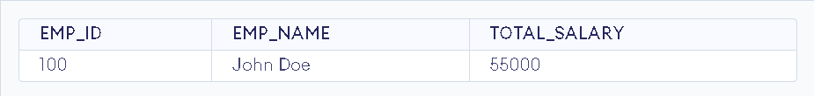

# EXERCISE 16

**AIM:** To Write a PL/SQL code to find the greatest of three numbers.

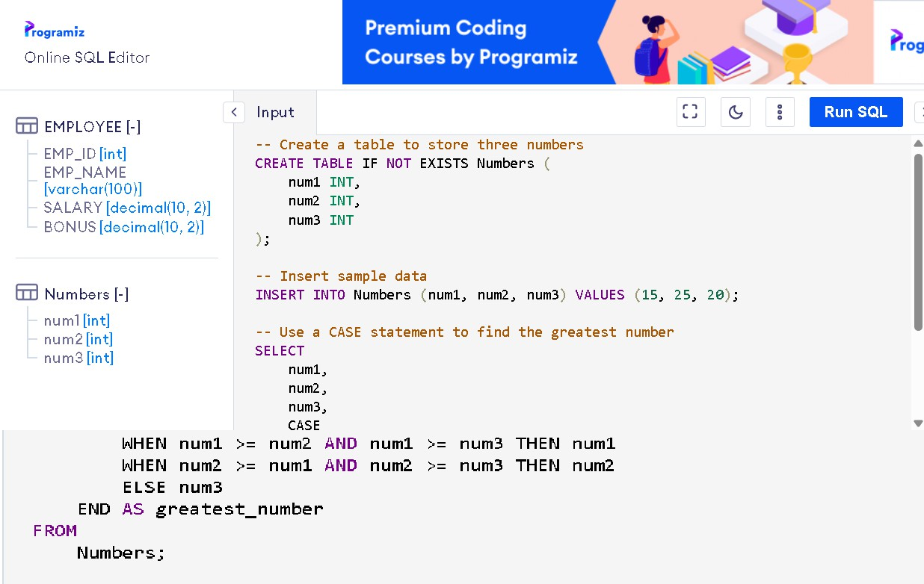

## OUTPUT:

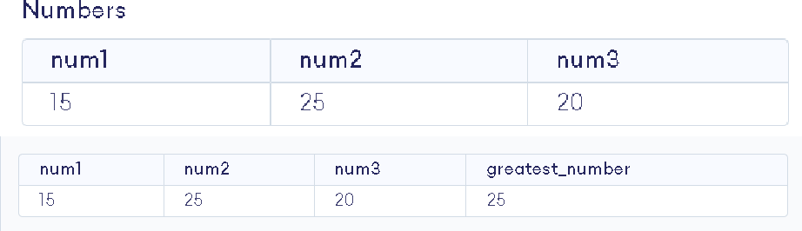

**AIM:** To Write a PL/SQL code to print the numbers from 1 to n.

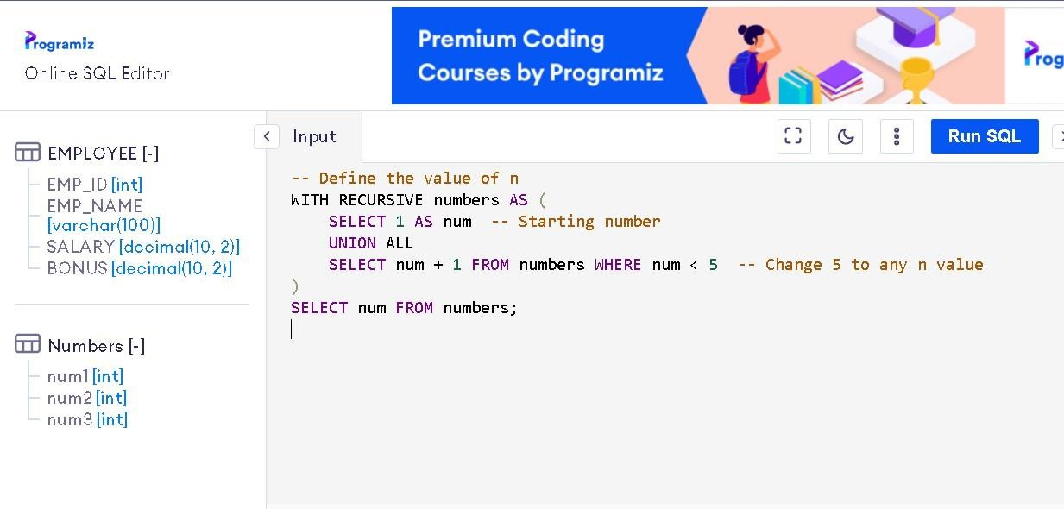

## OUTPUT:

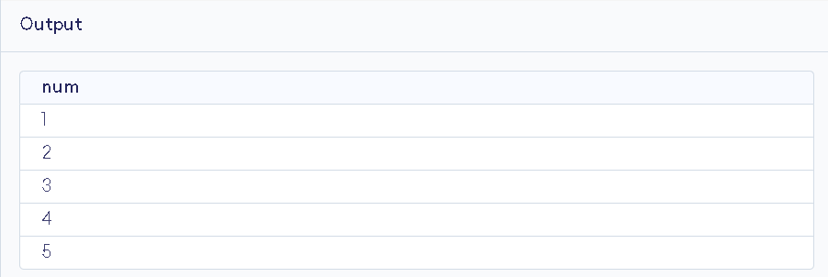

**AIM:** To Write a PL/SQL code to reverse a string using for loop.

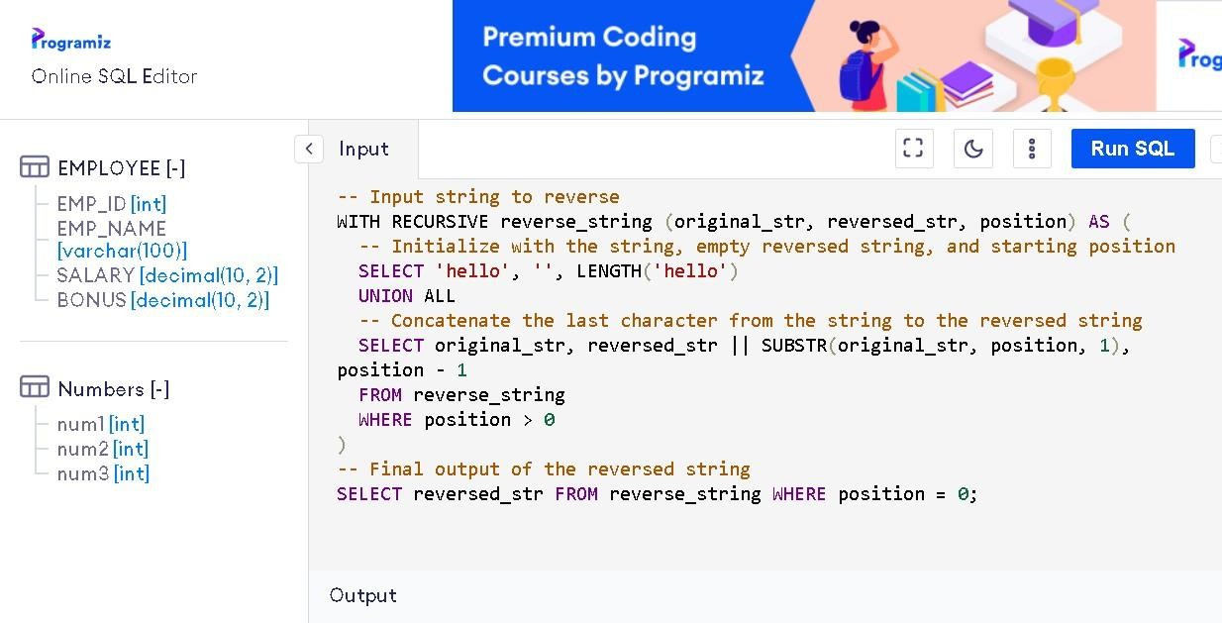

## OUTPUT:

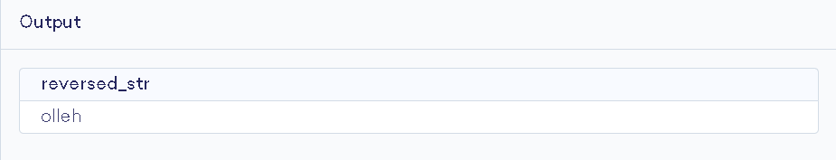

**AIM:** To Write a PL/SQL code to find the sum of n numbers.

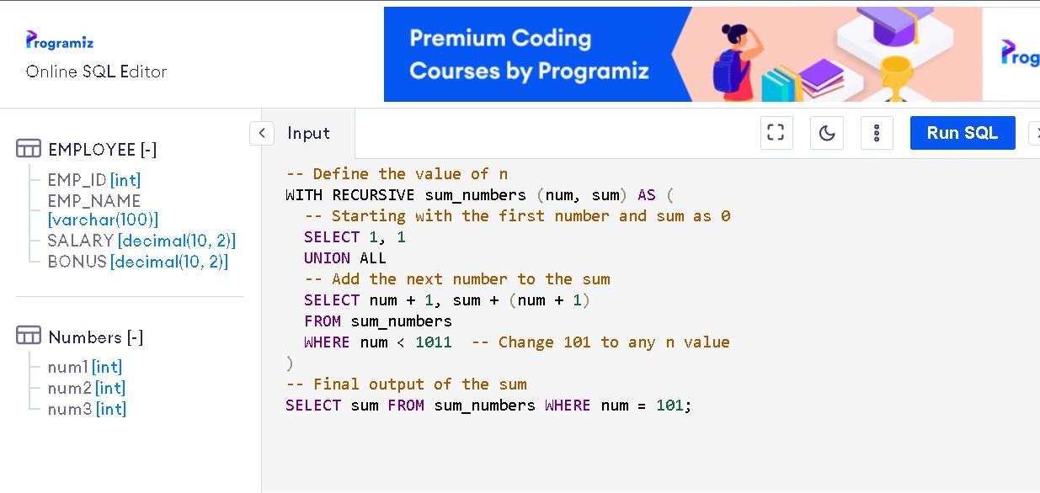

## OUTPUT:

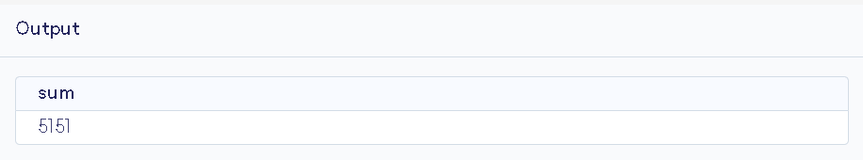

**AIM:** To Consider a PL/SQL code to display the empno, ename, job of employees of departmentnumber 10.

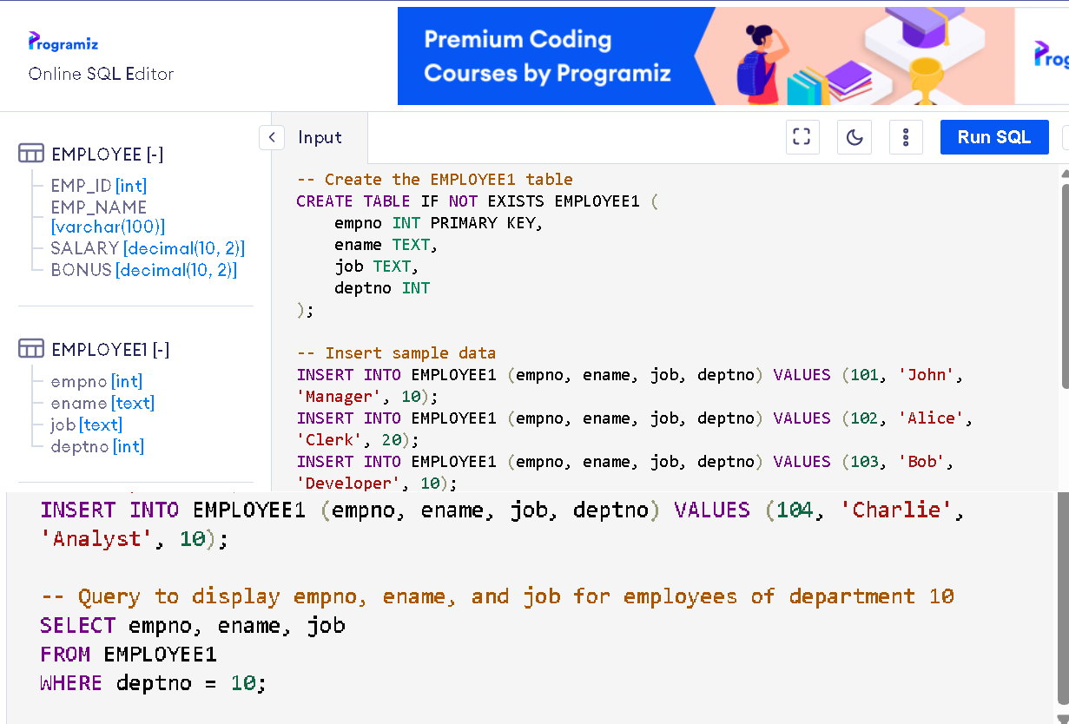

## OUTPUT:

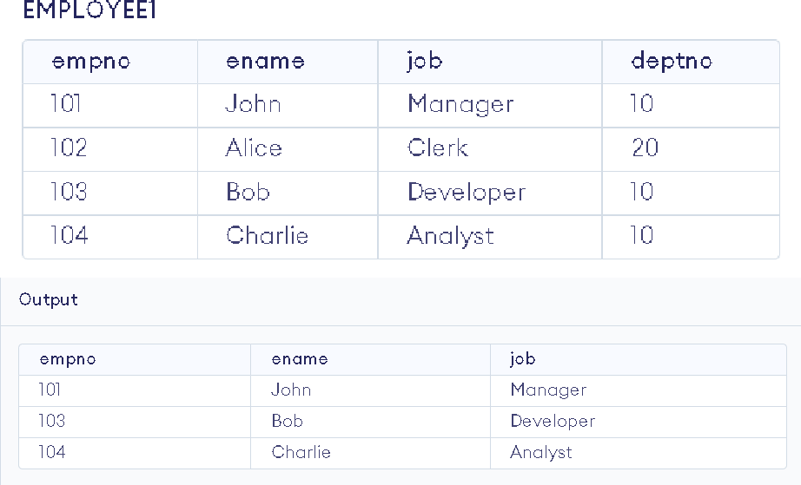

**AIM:** To Consider a PL/SQL code to display the employee number & name of top five highestpaid employees.

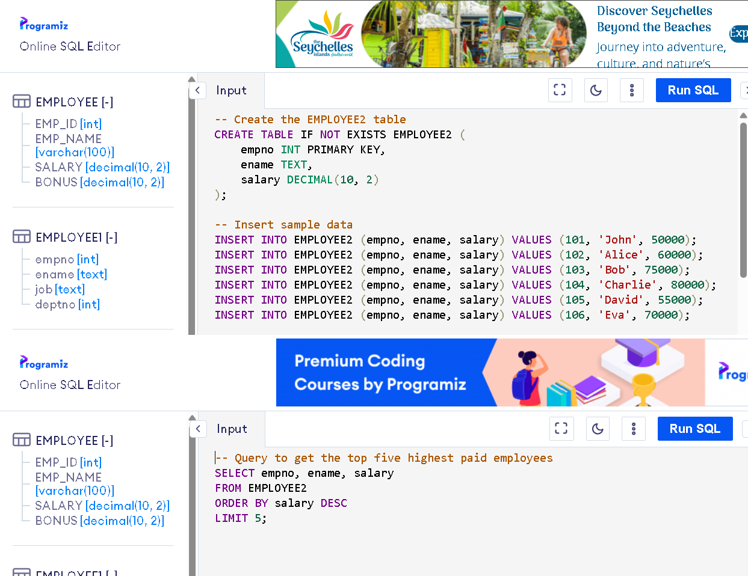

## OUTPUT:

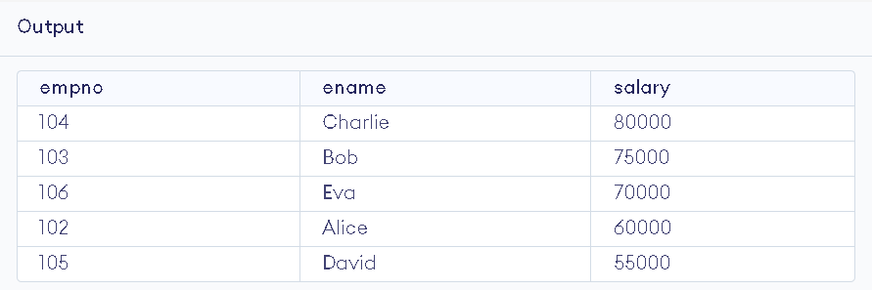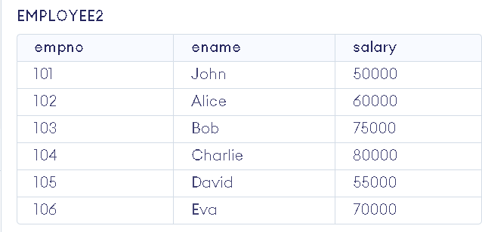

**AIM:** To Consider a PL/SQL procedure that accepts 2 numbers & return addition, subtraction,multiplication & division of two numbers using stored procedure AND local procedure.

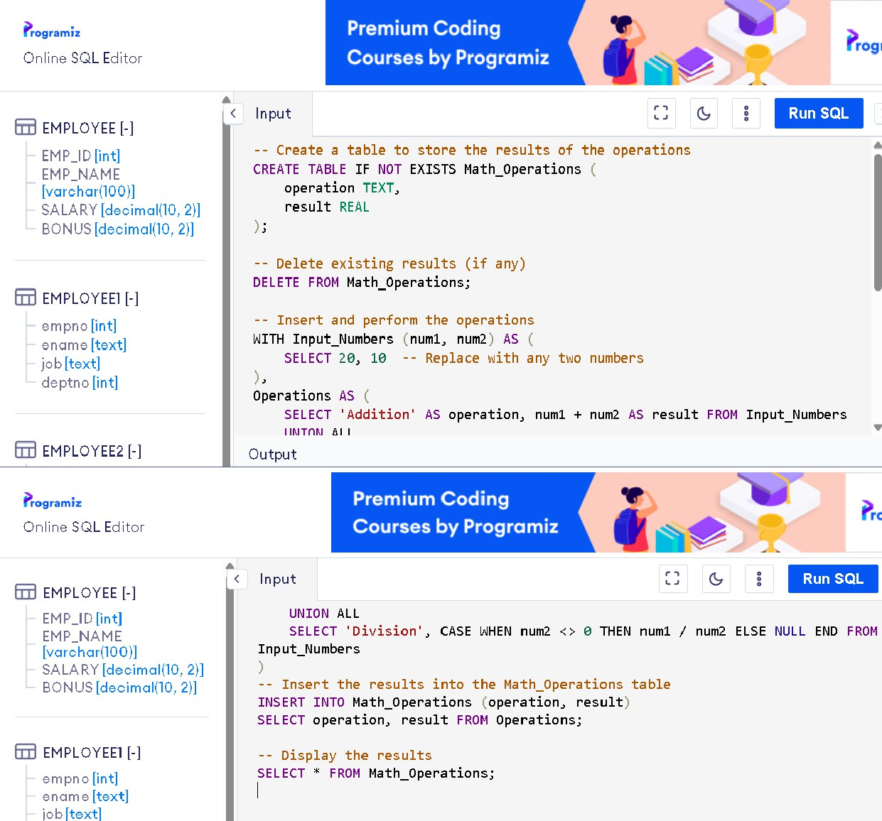

## OUTPUT:

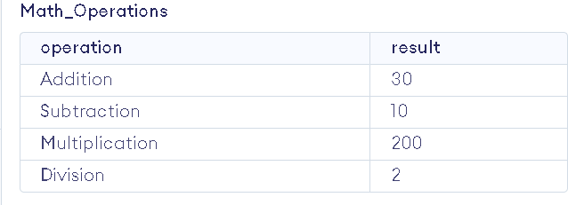

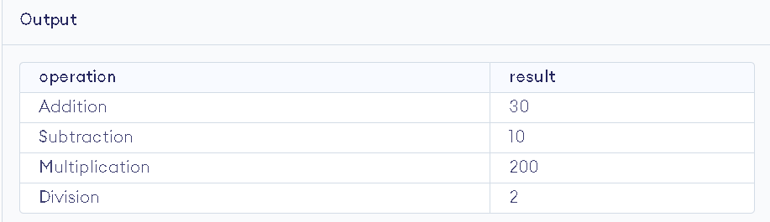

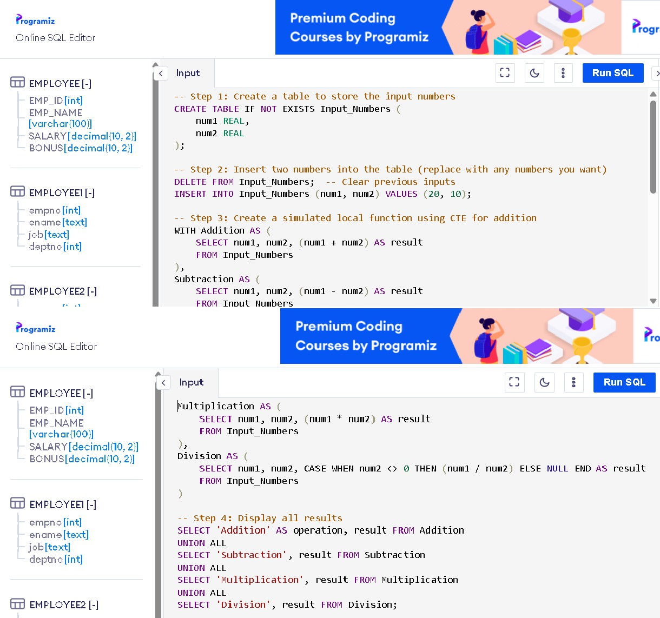**AIM:** To Consider a PL/SQL code that accepts 2 numbers & return addition, subtraction,multiplication & division of two numbers using stored functions and local function.

## OUTPUT:

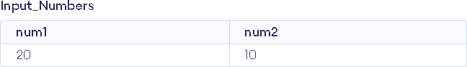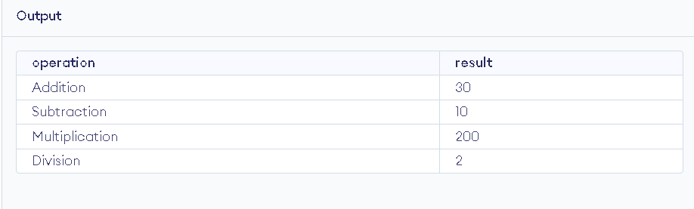

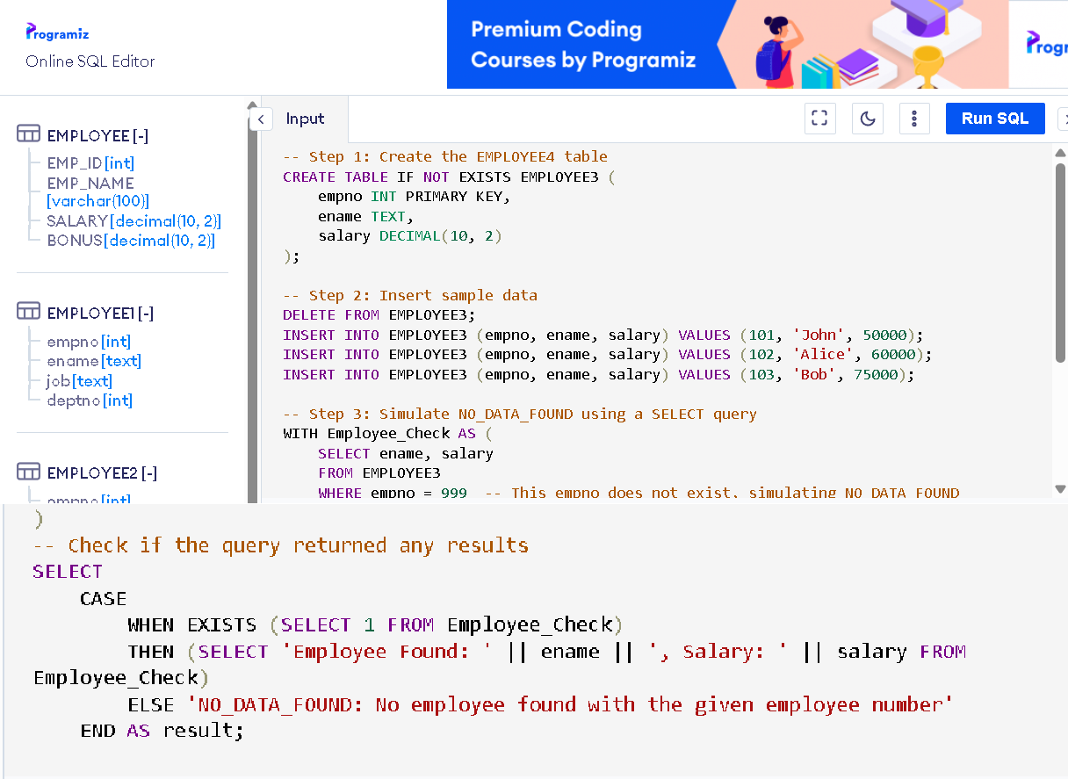**AIM:** To Write a PL/SQL block to show the use of NO_DATA FOUND exception.

## OUTPUT:

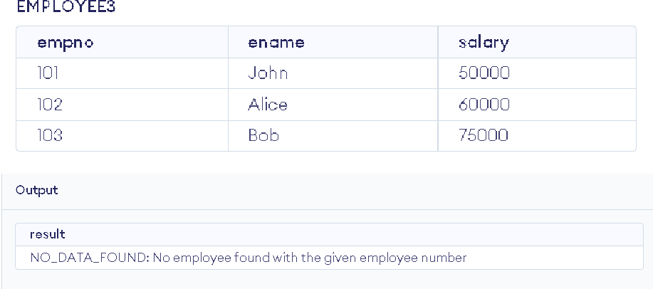

**AIM:** To Write a PL/SQL block to show the use of TOO_MANY ROWS exception.

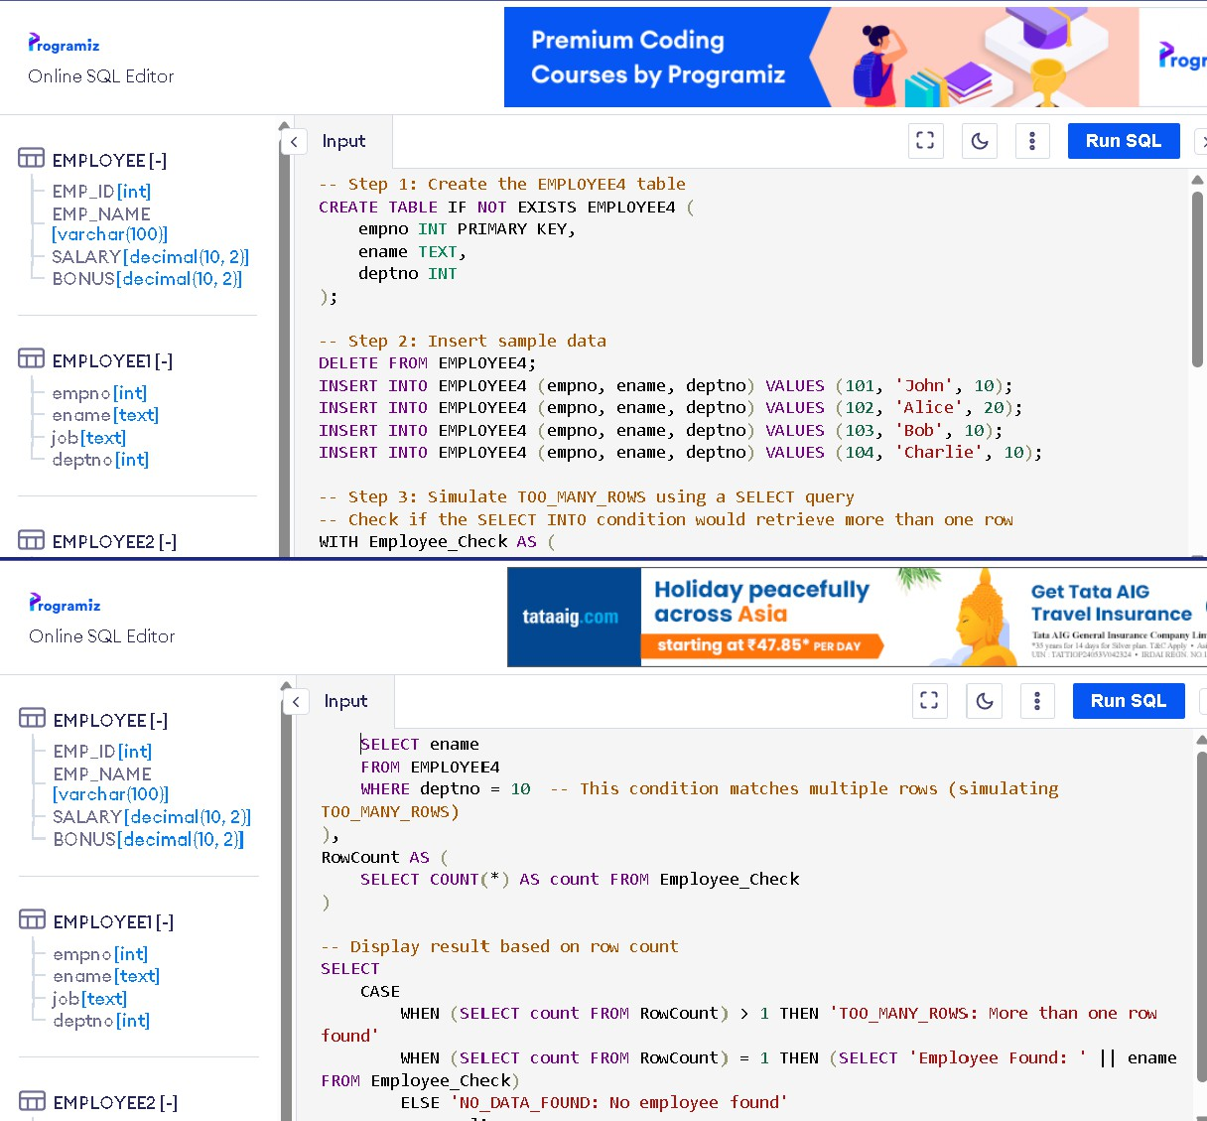

**OUTPUT:**

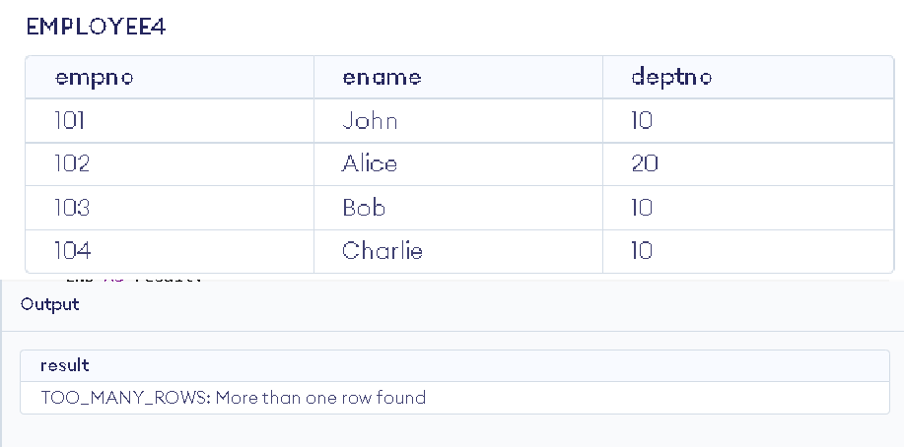

**AIM:** To Write a PL/SQL block to show the use of ZERO_DIVIDE exception.

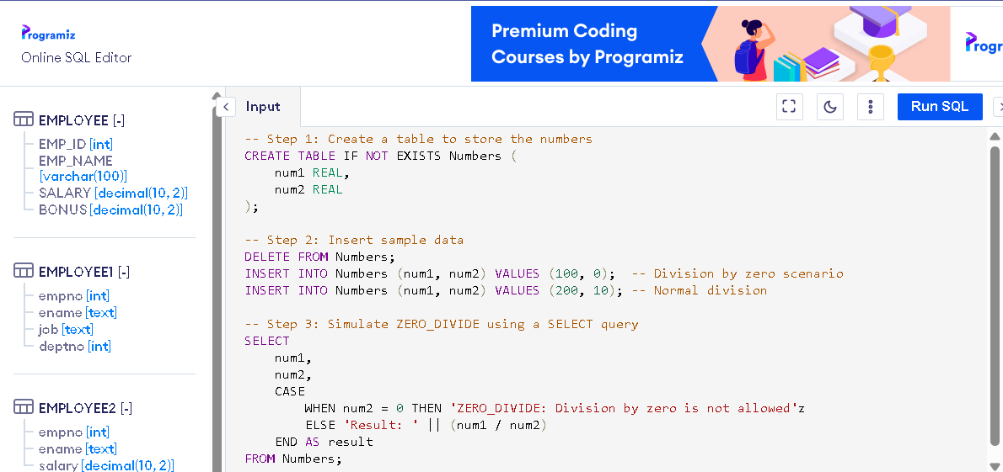

## OUTPUT:

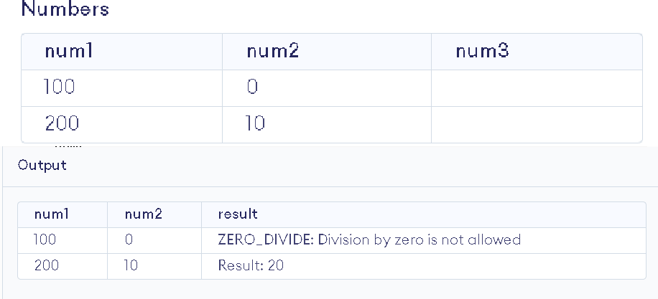

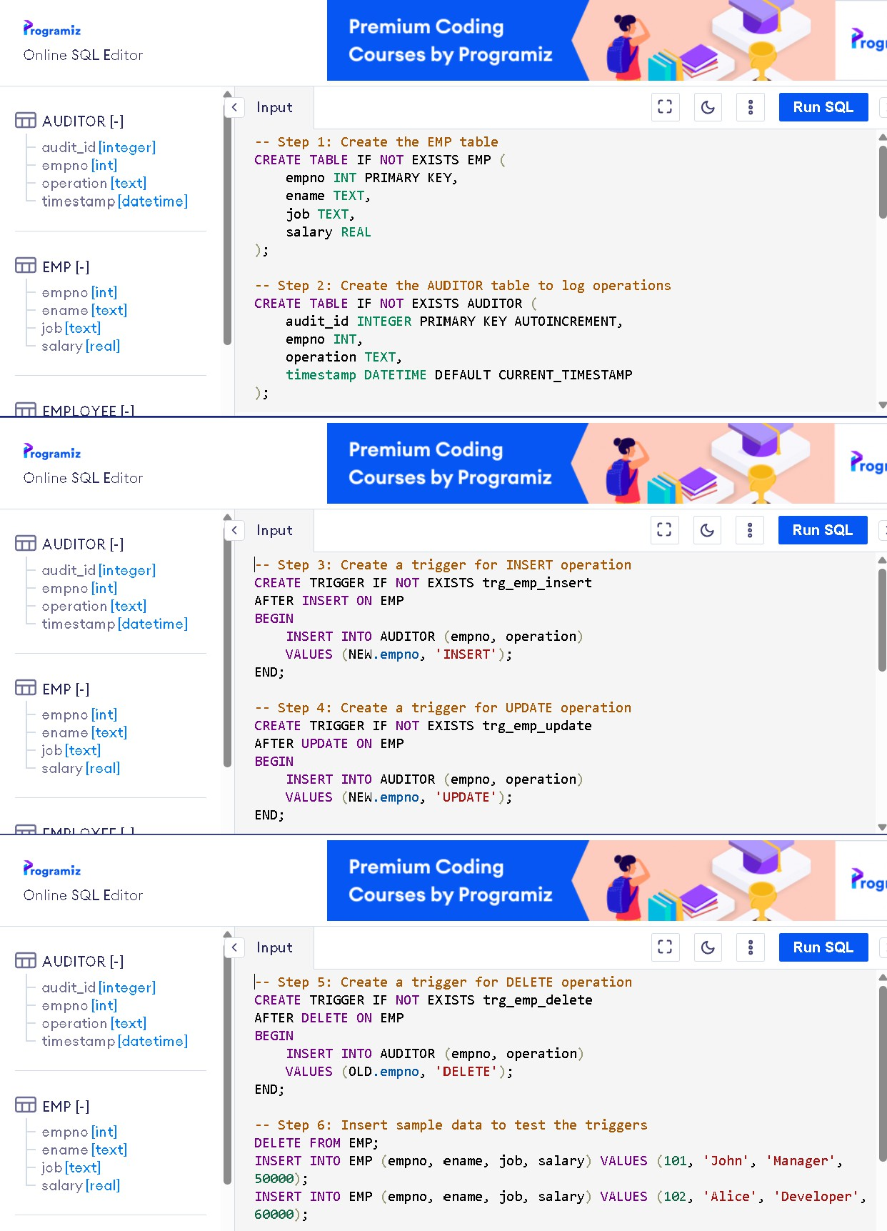**AIM:** To create a trigger on the emp table, which store the empno& operation in the table auditorfor each operation i.e. Insert, Update & Delete.

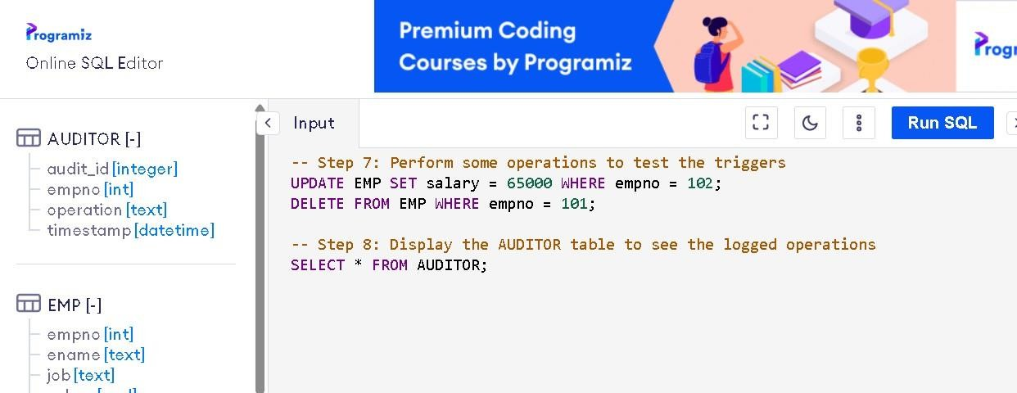

**OUTPUT:**

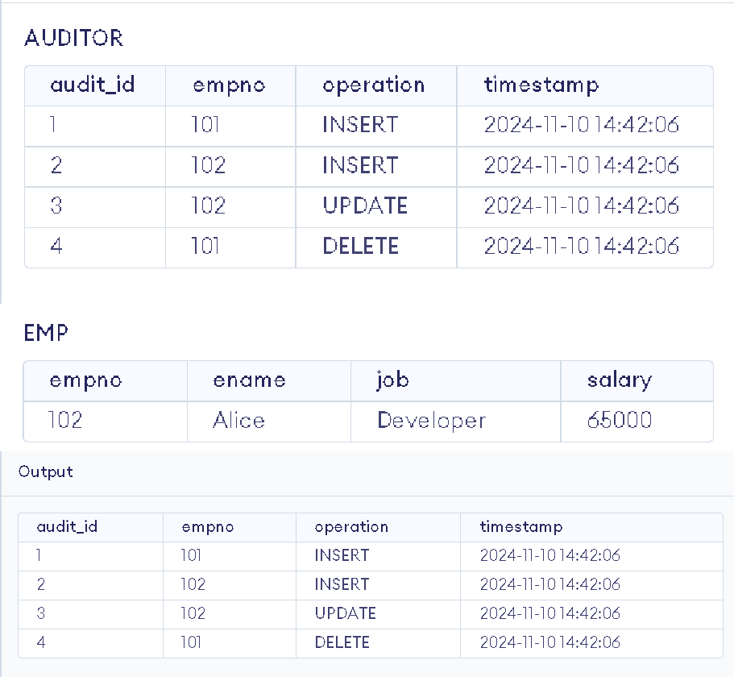

# EXERCISE 28

**AIM:** To create a trigger so that no operation can be performed on emp table.

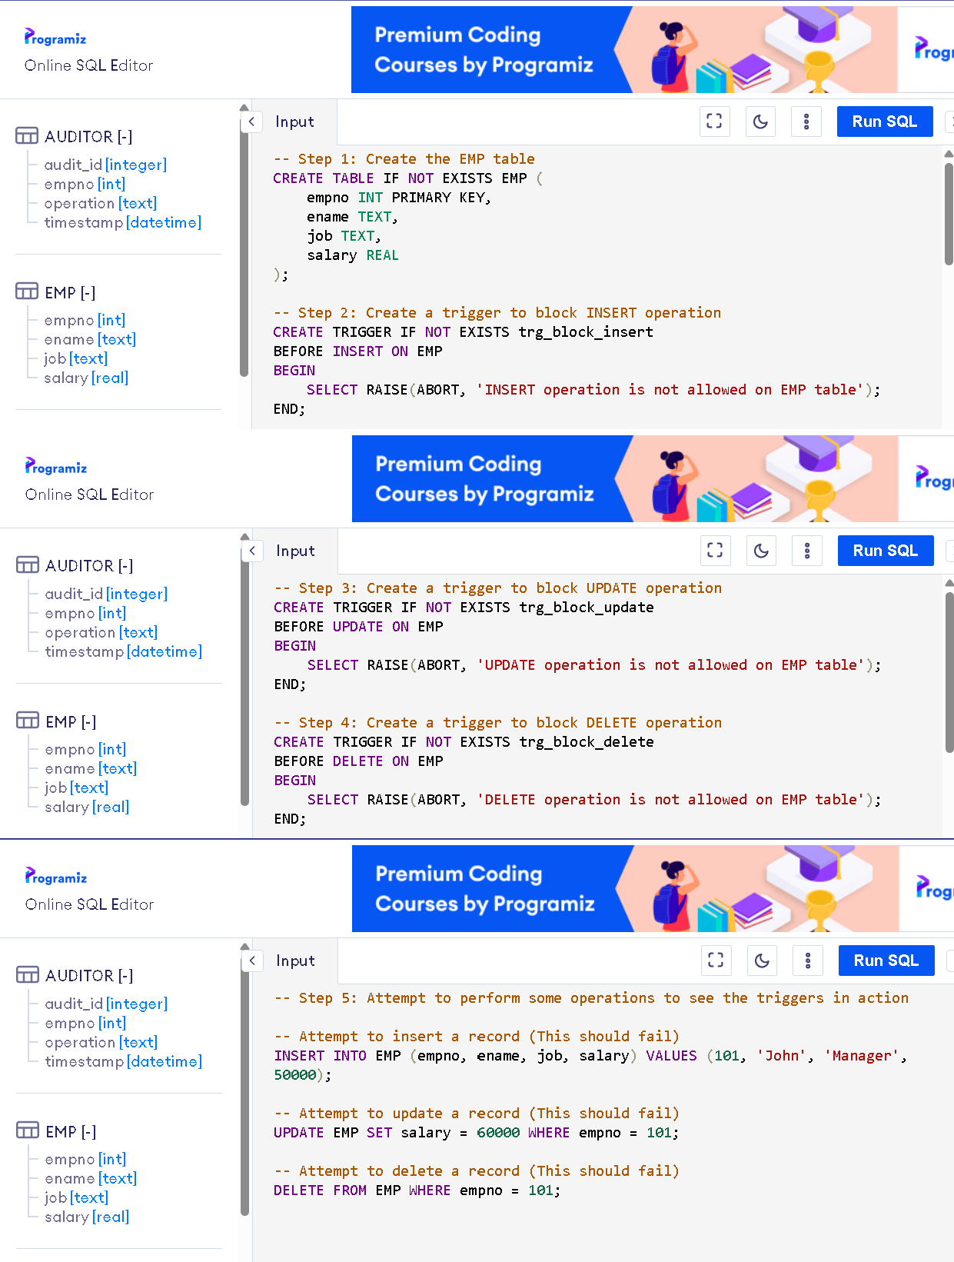

**OUTPUT:**

